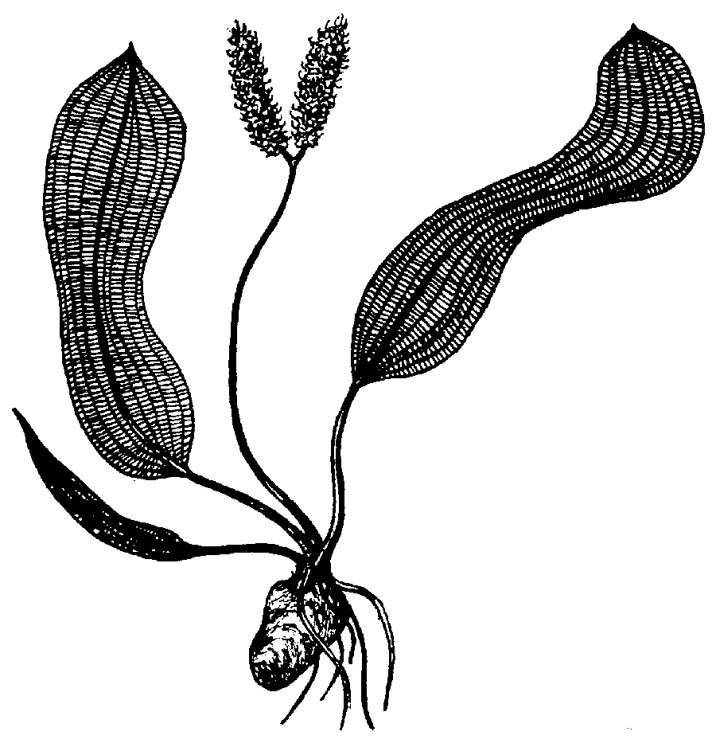
July 31, 2026
Aquatic Gardeners Association
306 NW 82nd Street, Seattle, WA 98117
www.aquatic-gardeners.org
Marian Wojtaszek
ul. Samborska 57
67-200 Głogów
Poland
Dear Marian:
On behalf of the Aquatic Gardeners Association, I would like to cordially invite you to attend our fifth annual convention in Washington, DC, the weekend of November 12th-14th, 2004. The featured guests are Takashi Amano and Jan Bastmeijer, but in addition there are two other speakers, four workshops, and the Aquascaping Contest awards at our Saturday night banquet. Please visit our website
http://www.aquatic-gardeners.org/convention.html for the schedule, fee information, and online booking.
Sincerely,
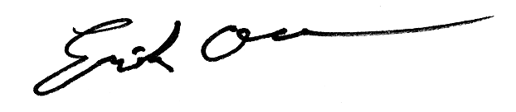
Erik Olson
AGA President

