For more information contact:
Valerie Grove
1207 Afton Street
Houston, TX 77055-7021
1-713-956-5585
email:vgrove@houston.rr.com

Charlene Nash
Tennessee Aquarium
PO Box 11048
Chattanooga, TN 37401.
1-800-262-0695
1-423-785-4071
email:ecn@tennis.org



Aquatic Gardeners Conference

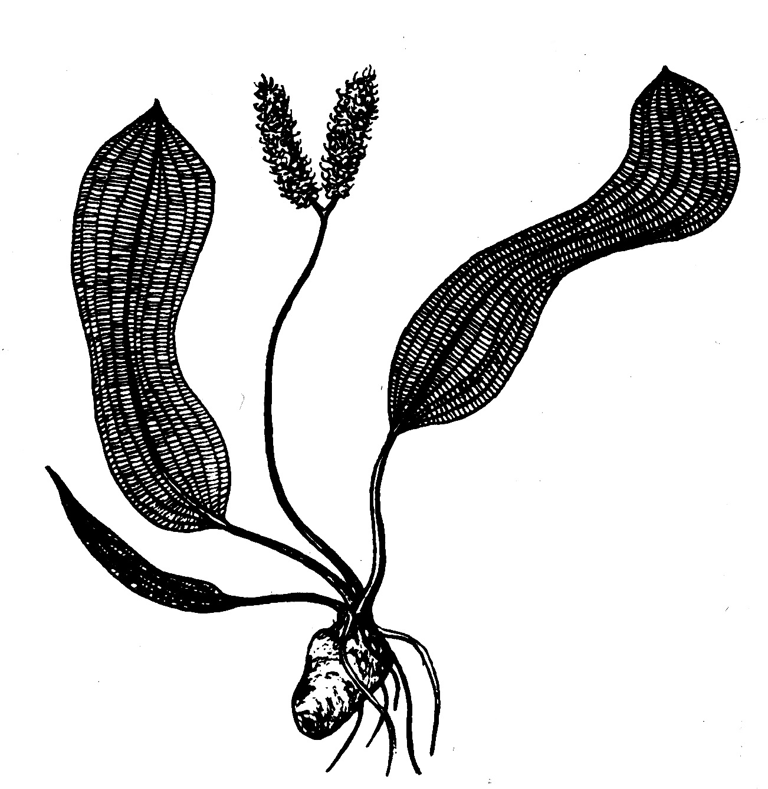
November 8, 9, 10, 2002
Hilton Houston Southwest
Houston, Texas

Put your boots on and join members of the Aquatic Gardeners Association for a fun-filled weekend of activities and Texas hospitality while networking with hobbyists and professionals on the art and science of keeping planted aquariums.

Hotel : Hilton Houston Southwest
6780 Southwest Freeway
Houston, TX 77074-2102
Phone: 713-977-7911
Fax: 713-974-5808

Hotel reservations will be made directly to the Hilton Hotel on a first come basis before Oct.1 which is the date the reserved rooms will be released to the public. Check in time is 3:00 and check out is 11:00 a.m. Room rates are $69.00 plus 17% tax.
SCHEDULE OF EVENTS
Friday, November 8, 2002.
12:00pm – 6:00pm. Registration, Hilton
3:00 Shuttles Begin for tours.**
7:00 Barbeque, Aquarium Environments.

Saturday, November 9, 2002:
7-8 a.m.: Continental Breakfast
Hilton Atrium
8a.m.-4p.m.: Ballroom

Speakers

GUEST SPEAKER: Claus Christensen
“Aquatic Plants in Nature and Culture”
Jeff Senske: “Aquascaping”
Erik Olson: “Photography of the Planted Aquarium”
Chuck Gadd: “Plants: Nature’s Test Kit ”
Don Kingore of Kent Marine: “Fertilization of the Planted Tank”

Lunch Included.

7p.m.: Banquet and cash bar.

Sunday, November 10, 2002: Hilton Hotel
7:30-8:30 a.m.: Continental Breakfast
8:30-9:30a.m.: Panel discussion-hotel ballroom
10:00 a.m. - 12:00 p.m.: Silent auction. Please bring your favorite unusual or rare aquatic plants to be auctioned.
Lunch on your own.

TRAVEL ARRANGEMENTS:
Please make hotel reservations directly with the Hilton Houston Southwest.
Both Hobby and Bush Intercontinental Airport are convenient to the Hilton.
Since there are no hotel shuttles, taxi's must be used.

**Shuttles leave about every half hour to take registrants to tour Village Tropical, and Aquarium Design Group then on to Aquarium Environments, our host for the evening barbecue dinner. If you arrive early at Aquarium Environments, there are plenty of boutiques, etc for shopping until 7.
Schedule of events is subject to change.

