

1st 6 Months 2005 Treasurer’s Report to the Board

“If you work just for money, you'll never make it, but if you love what you're doing and you always put the customer first, success will be yours.”
Ray Kroc (1902-1984)
Noble words from the man that sold people Big Macs for food.

"If all else fails immortality can be assured by a spectacular error."
John Kenneth Galbraith(1908- )

I call this a “Report to the Board” because I figure that anyone who reads this will be. But here goes. . .

Highlights

In the period, AGA had gross revenues of $16,822. Gross expenses were $12,430. Funds increased a total of $4,692 by the end of the six months. That is a gain in cash assets of 12%. Pause now to pat yourselves on the back; you deserve it. These are hard data, with a tiny bit of rounding thrown in for readability.

Money Producers and Consumers

Producers. The bar chart “1st 6 Months 2005 Revenues” shows that AGA memberships brought in the most money (nearly $9,500) followed by TAG Ads ($2,900) and DVD/CD sales ($2,385). Which leads me to say, if we do not pick up more advertisers, then Erik had better start coming up with more DVDs. Books moved to fourth place at a little less than $1,000, which was about 30% more than sales of TAGs (and PAMs), which brought in about $760. Plus we received a couple of hundred bucks for T-Shirts. Thus, T-Shirts are still nothing to sneeze at (or into). The relative amounts are shown in the pie chart below.

[This space conspicuously left blank]

Consumption of Funds. Not surprisingly, TAG production and distribution is our most costly endeavor, costing about $6,200 for printing, plus nearly $2,600 for mailing, layout and editing. Printing alone amounted to nearly half AGA expenses (see accompanying pie chart below). Nothing else comes even close to the TAG production and distribution costs.

[This space provided for your personal note-taking]

Contributions Based only on Direct Revenues and Expense

Before considering the allocation of overheads and general revenues and expenses, let us take a look at how the business activities contributed to the AGA net revenues for the period. Taking the gross revenues and expenses that are directly attributable to the specific business activities, we can see that TAG accounts for 63% of the net revenues with DVD/CDs providing about 1/3 that amount and books about half the amount of DVD/CDs. The picture is the same after allocating to these activities the general revenues and overhead expenses.

Contributions to Net Revenues After Allocating All Revenues and Expenses

What are the general revenues and expenses? They are these items for which we spent funds to advance AGA business in general:

Foreign Shipping 66.00
Ads (110.00)
Paypal Fees (445.00)
Office (448.80)
Brochure (728.00)
Postage and Delivery (590.17)

If we allocate these items to the business activities based on each activity’s share (percentage) of gross revenues, the relative net contribution to net revenues is the same as before allocations. In other words, the percentages are the same and only the absolute amounts change.

Downdate on Tax Status

Repeating what now should be obvious to all of you, the Federal government recognizes the AGA as a tax-exempt corporation. under subsection 501(c)4, which subsection applies to civic organizations that operate primarily for the promotion and common welfare of the community. So the next time someone says to you, “Ya done good,” it might have a social context.

Suggested Further Reading:

Nonfiction:
Democracy Matters, by Cornel West, 2004
Ketchup Matters, Betty Crocker, 1947
Wasteland and Other Poems, T.S. Elliot, various reprints available
Disneyland, or Visiting California on only $5,000 a day, P.J. O’Rourke 1981

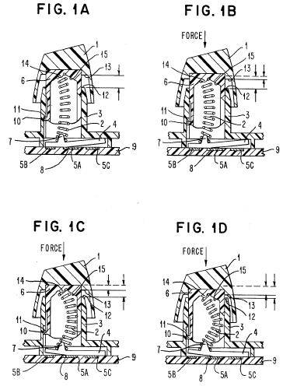
Buckling spring torsional
snap actuator, U.S. Patent 4,118,6; 1978

Fiction:
Aquarium plants The Practical Guide" Pablo Tepoot 1998

