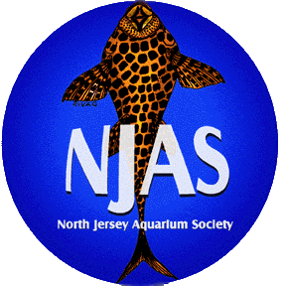

North Jersey Aquarium Society

presents

Giant Benefit Auction

For The John O’Malley Family

Thursday February 19, 2009
7:45 p.m.
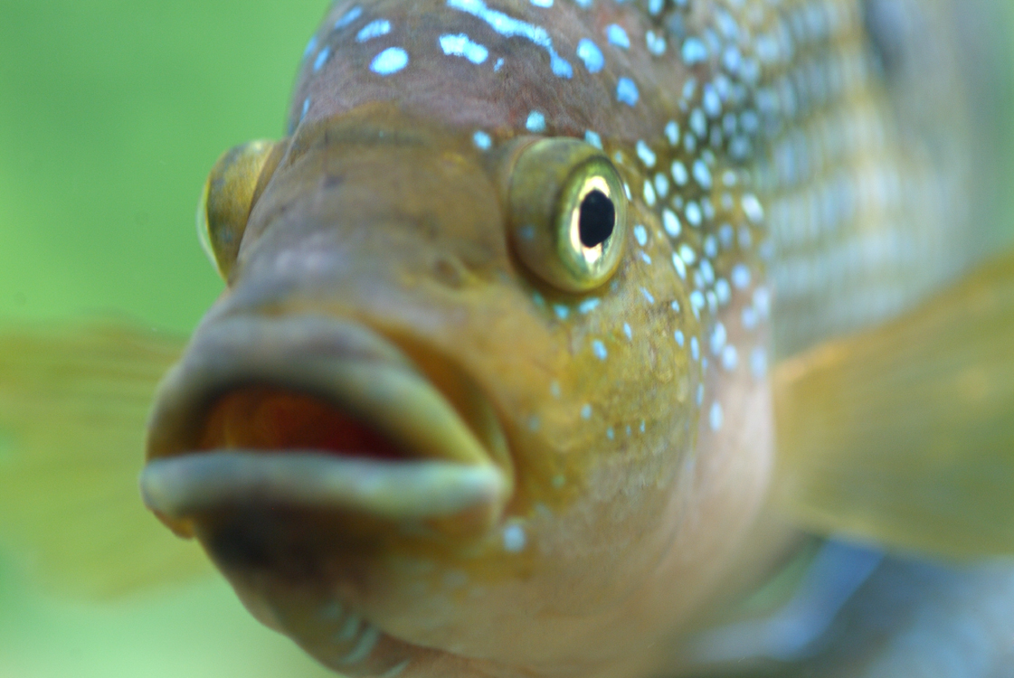
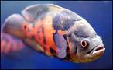

Elks Club

251 Park Avenue, Lyndhurst, NJ 07071

Auction will feature donations from expert breeders, renowned hobbyists, local pet shops and wholesalers like Tony Orso USA, Jeff Rapps of Tangled up in Cichlids, George Fear of Shark Aquarium and Lee Finley of Finley Aquatic Books.

No speaker – just a huge auction, free door prizes and bidder cards!

For more information contact
Kevin Carr @ 201-724-9460 or deadhead_kc@yahoo.com
Visit our website @ www.njas.net
Or call NJAS Hotline @ 732-541-1392

