
Proposal

Greater Washington Area Aquatic Plant Association

From: BWI Airport Marriott

July 30, 2026

Mr. Rick Dotson
Convention Chairperson
Greater Washington Area Aquatic Plant Association
9026 Dellwood Drive
Vienna, VA 22180

Dear Rick:

Below you will find all of the revisions discussed during our Meeting on Thursday and our conversation today.

We understand your Greater Washington Area Aquatic Plant Associations’ needs are as follows:

Room rates quoted below are exclusive of state required 12%tax

Single: $99
Double: $99

 | Thu  11/04 | Fri  11/05 | Sat  11/06
Run of House | 45 | 90 | 90

FUNCTION SPACE SCHEDULE

Date | Start Time | End Time | Function | Room | Setup | Agr | Room Rental
11/4/2004 | 6:00 PM | 11:30 PM | Hospitality | Presidental Suite 926 |  |  | 275.00
11/5/2004 | 12:00 PM | 7:00 AM | Other | Pennsylvania
11/6/2004 | 7:00 AM | 10:00 PM | Other | Pennsylvania
11/6/2004 | 8:00 AM | 2:00 PM | General Session | Salon ABCDE | Theatre | 250 | 1,600.00
11/6/2004 | 10:00 AM | 10:30 AM | Break | Foyer ABC | Station | 250
11/6/2004 | 3:00 PM | 3:30 PM | Break | Foyer ABC | Station | 250
11/6/2004 | 3:30 PM | 6:00 PM | Breakout | Salon A | Schoolroom | 40 | 200.00
11/6/2004 | 3:30 PM | 6:00 PM | Breakout | Salon B | Schoolroom | 40 | 200.00
11/6/2004 | 3:30 PM | 6:00 PM | Breakout | Salon C | Schoolroom | 40 | 200.00
11/6/2004 | 3:30 PM | 6:00 PM | Breakout | Salon D | Theatre | 70 | 250.00
11/6/2004 | 3:30 PM | 6:00 PM | Breakout | Salon E | Schoolroom | 110 | 600.00
11/6/2004 | 7:00 PM | 10:00 PM | Dinner | Salon ABCDE | Rounds Of 10 | 250 | 1,600.00
11/7/2004 | 8:00 AM | 5:00 PM | General Session | Salon ABCD | Theatre | 250 | 1,150.00
11/7/2004 | 10:00 AM | 10:30 AM | Break | Foyer ABC | Station | 250
11/7/2004 | 3:00 PM | 3:30 PM | Break | Foyer ABC | Station | 250

Due to licensing requirements and quality control issues, all food and beverage to be served on the hotel property must be supplied and prepared by the hotel.

All food and beverage & room rental prices are subject to a 21% service charge and a 5% state tax subject to change without notice. Please note that the service charge is taxable.

BWI Marriott Function Space

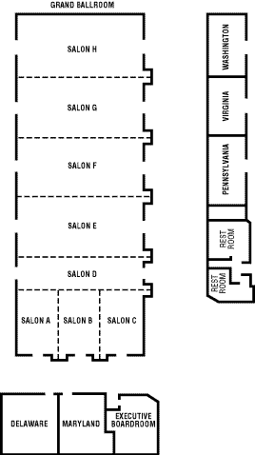
Rick, I have booked the space anticipating aproximately 250-300 attendees and 225 room nights. After review of this proposal please let me know of any changes you would like to make.

I look forward to speaking with you soon.

Sincerely,

Christian Jones
Sales Manager
(INSERT EMAIL ADDRESS)
http://www.marriotthotels.com/BWIAP

