The Aquatic Gardeners Association, Inc.
Presents the 2004

AGA Convention!

November 12, 13 & 14, 2004 Arlington, VA

Hosted by the Greater Washington Aquatic Plant Association www.gwapa.org
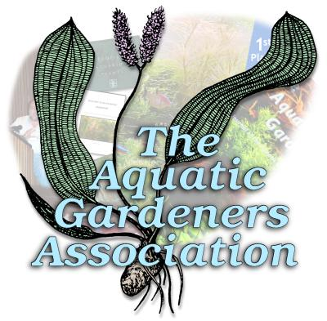

Join the members of the Aquatic Gardeners Association for a weekend of full of fun and learning! Whether you are a casual hobbyist or an experienced professional, your planted aquariums will thank you.

Mark your calendar now. The weekend’s activities include a fun field trip, information packed presentations from renowned experts including aquascaping master Takashi Amano sharing his art and techniques, designing an aquascape before your eyes. Plus focus groups, a banquet and an auctions on Sunday that will include rare plants.

More details will be available soon on the AGA website (www.aquatic-gardeners.org) and the GWAPA website. A complete informational brochure will be mailed to all AGA members. For your convenience, in additional to mail-in registration, on-line registration will be available through those websites.
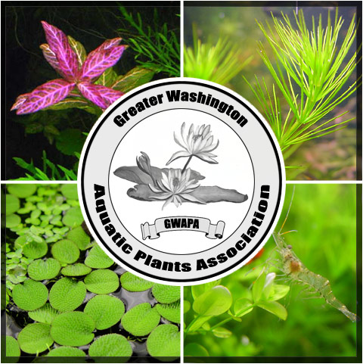
The Aquatic Gardeners Association, Inc.
Presents the 2004

AGA Convention!

November 12, 13 & 14, 2004 Arlington, VA

Hosted by the Greater Washington Aquatic Plant Association www.gwapa.org

Join the members of the Aquatic Gardeners Association for a weekend of full of fun and learning! Whether you are a casual hobbyist or an experienced professional, your planted aquariums will thank you.

Mark your calendar now. The weekend’s activities include a fun field trip, information packed presentations from renowned experts including aquascaping master Takashi Amano sharing his art and techniques, designing an aquascape before your eyes. Plus focus groups, a banquet and an auctions on Sunday that will include rare plants.

More details will be available soon on the AGA website (www.aquatic-gardeners.org) and the GWAPA website. A complete informational brochure will be mailed to all AGA members. For your convenience, in additional to mail-in registration, on-line registration will be available through those websites.
The Aquatic Gardeners Association, Inc.
Presents the 2004

AGA Convention!

November 12, 13 & 14, 2004 Arlington, VA

Hosted by the Greater Washington Aquatic Plant Association www.gwapa.org

Join the members of the Aquatic Gardeners Association for a weekend of full of fun and learning! Whether you are a casual hobbyist or an experienced professional, your planted aquariums will thank you.

Mark your calendar now. The weekend’s activities include a fun field trip, information packed presentations from renowned experts including aquascaping master Takashi Amano sharing his art and techniques, designing an aquascape before your eyes. Plus focus groups, a banquet and an auctions on Sunday that will include rare plants.

More details will be available soon on the AGA website (www.aquatic-gardeners.org) and the GWAPA website. A complete informational brochure will be mailed to all AGA members. For your convenience, in additional to mail-in registration, on-line registration will be available through those websites.
Preliminary Schedule of Events*

Friday, November 12th
^{Field trip}
Convention opening presentation

Saturday, November 13th
Speaker Presentations and Focus Groups
Banquet, including Keynote Speaker Presentation & AGA 2004 Annual Aquascaping Contest Awards Ceremony.

Sunday November 14th

Live & Silent auctions of Plants & general merchandise

*Detail available soon on the AGA and GWAPA websites

Registration & Fees

Convention Registration – Members $49 for the 1st 50 people to register, $59 thereafter until October 27th
Nonmembers -- $69** for the 1st 50 people to register, $79** thereafter until October 27^{th**}
Additional $20 after October 27th
**Includes one-year membership in AGA and subscription to The Aquatic Gardener, the full-color official journal of the AGA.

Banquet – $39

Field Trip – To be Determined

Hotel room – $99 single $109 double – Triples & Quads available while they last.
Contact the Marriot Crystal Gateway, 1700 Jefferson Davis Highway, Arlington, VA, 22202; 1-800-228-9290. Be sure to mention the AGA to get the special convention rates & ensure that AGA gets credit for your attendance. On-line registration should be available soon – check the AGA & GWAPA websites for details.

The elegant Marriot Crystal Gateway is just minutes away from Washington’s Reagan National Airport via the Metro rail system. All of Washington, D.C.’s great restaurants and national and historic sites are also minutes away via Metro. Don’t forget to save a day for visiting the (free admission) National Air & Space Museum, the National Gallery and other Federal govt. sites.

See You There!
Preliminary Schedule of Events*

Friday, November 12th
^{Field trip}
Convention opening presentation

Saturday, November 13th
Speaker Presentations and Focus Groups
Banquet, including Keynote Speaker Presentation & AGA 2004 Annual Aquascaping Contest Awards Ceremony.

Sunday November 14th

Live & Silent auctions of Plants & general merchandise

*Detail available soon on the AGA and GWAPA websites

Registration & Fees

Convention Registration – Members $49 for the 1st 50 people to register, $59 thereafter until October 27th
Nonmembers -- $69** for the 1st 50 people to register, $79** thereafter until October 27^{th**}
Additional $20 after October 27th
**Includes one-year membership in AGA and subscription to The Aquatic Gardener, the full-color official journal of the AGA.

Banquet – $39

Field Trip – To be Determined

Hotel room – $99 single $109 double – Triples & Quads available while they last.
Contact the Marriot Crystal Gateway, 1700 Jefferson Davis Highway, Arlington, VA, 22202; 1-800-228-9290. Be sure to mention the AGA to get the special convention rates & ensure that AGA gets credit for your attendance. On-line registration should be available soon – check the AGA & GWAPA websites for details.

The elegant Marriot Crystal Gateway is just minutes away from Washington’s Reagan National Airport via the Metro rail system. All of Washington, D.C.’s great restaurants and national and historic sites are also minutes away via Metro. Don’t forget to save a day for visiting the (free admission) National Air & Space Museum, the National Gallery and other Federal govt. sites.

See You There!
Preliminary Schedule of Events*

Friday, November 12th
^{Field trip}
Convention opening presentation

Saturday, November 13th
Speaker Presentations and Focus Groups
Banquet, including Keynote Speaker Presentation & AGA 2004 Annual Aquascaping Contest Awards Ceremony.

Sunday November 14th

Live & Silent auctions of Plants & general merchandise

*Detail available soon on the AGA and GWAPA websites

Registration & Fees

Convention Registration – Members $49 for the 1st 50 people to register, $59 thereafter until October 27th
Nonmembers -- $69** for the 1st 50 people to register, $79** thereafter until October 27^{th**}
Additional $20 after October 27th
**Includes one-year membership in AGA and subscription to The Aquatic Gardener, the full-color official journal of the AGA.

Banquet – $39

Field Trip – To be Determined

Hotel room – $99 single $109 double – Triples & Quads available while they last.
Contact the Marriot Crystal Gateway, 1700 Jefferson Davis Highway, Arlington, VA, 22202; 1-800-228-9290. Be sure to mention the AGA to get the special convention rates & ensure that AGA gets credit for your attendance. On-line registration should be available soon – check the AGA & GWAPA websites for details.

The elegant Marriot Crystal Gateway is just minutes away from Washington’s Reagan National Airport via the Metro rail system. All of Washington, D.C.’s great restaurants and national and historic sites are also minutes away via Metro. Don’t forget to save a day for visiting the (free admission) National Air & Space Museum, the National Gallery and other Federal govt. sites.

See You There!

