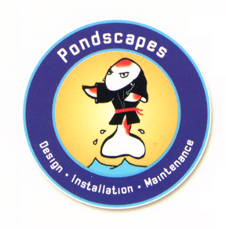
Pondscapes Inc.
125 Shadowlawn Dr.

Fishers, IN 46038
317-596-POND www.HoosierPonds.com

“We create waterfront property!”

Greg Speichert to speak at Pondscapes spring open house.
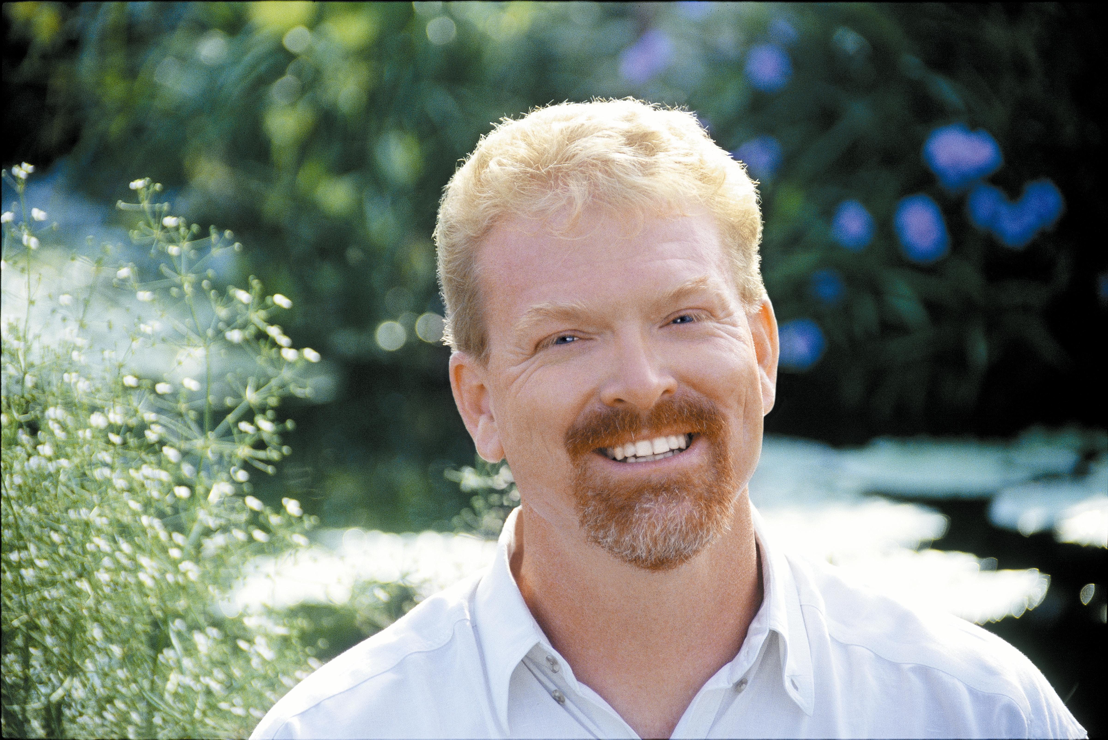

For Immediate Release.
Greg Speichert, will be speaking in Fishers Indiana on April 16th at the Pondscapes Pond Shop for their spring open house event. Greg is a nationally known author, publisher, and water gardening expert. Greg and the Pondscapes staff will be sharing tips and tricks to make your pond more enjoyable, or introduce you to a very rewarding and relaxing hobby, Water Gardening!

About Greg…
Greg Speichert is an accomplished horticulturist and avid plant breeder. He is a favorite speaker for plant societies, landscape organizations, and garden clubs. Author of three books on water gardening, Water Gardening in Containers (Co-author), Ortho’s All about Water Gardening, and Encyclopedia of Water Garden Plants. Greg’s articles have appeared in Fine Gardening, American Nurseryman, and Pondkeeper. His company, Crystal Palace Perennials develops and patents new plants, many of them hardy in northern climates.

About Pondscapes…
Located in Fishers, Pondscapes is central Indiana’s largest and most respected Pond Design, Installation, and Maintenance Company. Pondscapes opened its retail Pond Shop in May of 2004 with a seminar by Dr. Sandra Yosha on Koi and goldfish health. Pondscapes Pond Shop carries everything a pond keeper could need, including Koi and Goldfish from Japan’s best breeders. Pondscapes also carries a large assortment of aquatic plants, and teaches homeowners how to build and maintain their own ponds with their monthly “Build a Pond” seminars.
#ends#

For more information contact:
Jonathan Dooley @ 317-596-7663
Or

Pondscapes@sbcglobal.net

