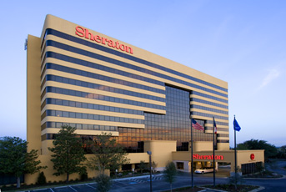
Sheraton Grand Hotel
Dallas/Fort Worth Airport

4440 W. John Carpenter Freeway ● Irving, TX 75063
Phone: 972-929-8400 ● Fax: 972-929-0983
www.sheratongranddfw.com

IN THE AREA

Conveniently located in the heart of the Dallas/Fort Worth Metroplex and only minutes from D/FW International Airport, the Sheraton Grand pampers its guests with sophisticated luxury and the finest of Texas hospitality. The 12-story, 303-room Sheraton Grand promises the ultimate in guest satisfaction. When you consider the hotel’s location, luxury accommodations and genuine hospitality, the Sheraton Grand is the perfect destination for business or pleasure.

ATTRACTIONS
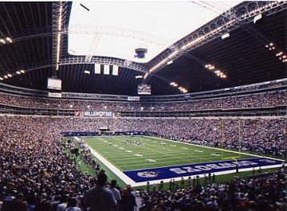
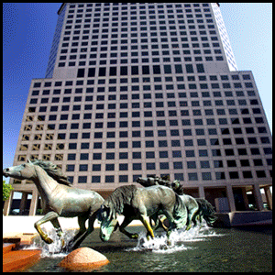

- 5 miles to Williams Square, home of the world’s largest bronze equine sculpture, the Mustangs of Las Colinas
- 7 miles to The Studios of Las Colinas
- 7 miles to Grapevine Mills Mall
- 8 miles to Texas Stadium, home of the NFL Dallas Cowboys
- 12 miles to The Galleria mall for shopping
- 15 miles to the American Airlines Center, home of the NBA Mavericks and NHL Dallas Stars
- 16 miles to the downtown West End Historic District, featuring a variety of nightclubs and entertainment
- 16 miles to The Ballpark of Arlington, home of the MLB Texas Rangers
- 16 miles to Six Flags Theme Park and Hurricane Harbor Water Park
- 17 miles to Market Center, Apparel Mart, Design District, World Trade Center
- 20 miles to Fair Park and the Cotton Bowl

TEMPERATURE
Dallas/Fort Worth Weather Averages
 | Jan | Feb | Mar | Apr | May | Jun | Jul | Aug | Sep | Oct | Nov | Dec | Annual
High Temp (°F) | 54.1 | 58.9 | 67.8 | 76.3 | 82.9 | 91.9 | 96.5 | 96.2 | 87.8 | 78.5 | 66.8 | 57.5 | 76.3
Low Temp (°F) | 32.7 | 36.9 | 45.6 | 54.7 | 62.6 | 70.0 | 74.1 | 73.6 | 66.9 | 55.8 | 45.4 | 36.3 | 54.6

TRANSPORTATION

- Dallas/Fort Worth International Airport is located 1.5 miles from the hotel
- Dallas Love Field is located 17 miles from the hotel
- Complimentary airport transportation is provided by the hotel 24 hours a day 7 days a week to/from DFW Airport
- Complimentary scheduled transportation to Grapevine Mills Mall and BassPro Shops Outdoor World
- Guest services can arrange for car rental pick-ups and drop-offs, as well as taxi transportation

ACCOMMODATIONS

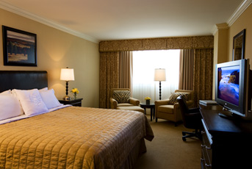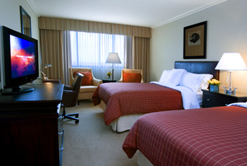

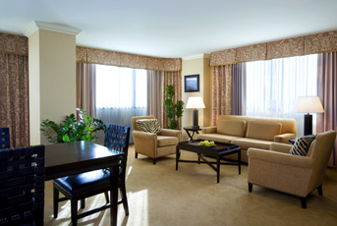

The award winning Sheraton Grand DFW boasts 303 beautifully appointed newly renovated guest rooms featuring
plush accommodations, Sweet Sleeper Beds and spacious work areas. Our exquisite suites are perfect for entertaining guests or holding impromptu meetings. The vast majority of guest rooms are non-smoking. All guest rooms have
makeup mirrors, hair dryers, irons, ironing board and coffeemakers with a complimentary supply of coffee replenished daily. In addition, all rooms feature two telephones with data ports and High Speed Internet access.
_______________________________________________________________________

Guest Room Inventory
Room Category | No. | Size | Special Features
Murphy Suite | 4 | 12 x 28 | King sofa or two doubles connecting to Murphy parlor with a Queen Murphy bed.
French Door Suite | 2 | 24 x 28 | Small parlor room for entertaining with French doors leading to a King bedroom.
Parlor Suite | 2 | 24 x 28 | Double wide parlor with living room and boardroom table seating eight people with a connecting King bedroom.
Presidential Suite | 1 | 24 x 28 | Double wide parlor with living room and boardroom table seating eight people with connecting bedrooms on each side (1 King & 1 Double).
Club King | 33 | 12 x 28 | Club Level access, Breakfast in the morning and Hors d’oeuvres in the evening.
Club Double | 17 | 12 x 28 | Club Level access, Breakfast in the morning and Hors d’oeuvres in the evening.
Deluxe King | 105 | 12 x 25 &  12 x 28 | Deluxe King with “Sheraton Sweet Sleeper” bed with plush down comforters; available in Smoking or Non-Smoking.
Deluxe King Sofas | 24 | 12x25 &  12 x 28 | Deluxe King with “Sheraton Sweet Sleeper” bed with plush down comforters; available in Smoking or Non-Smoking w/ a Queen size sofa sleeper
Deluxe Double | 111 | 12 x 25 &  12 x 28 | Two full size “Sheraton Sweet Sleeper” beds with plush down comforters; available in Smoking or Non-Smoking.
Accessible Rooms | 4 | 12 x 25 | King bedroom with oversized bathroom for wheelchair accessibility.

FOOD & BEVERAGE

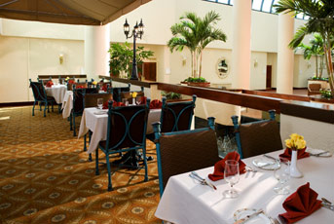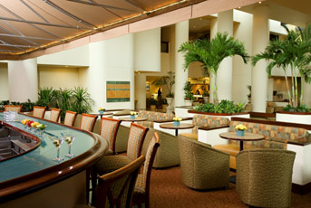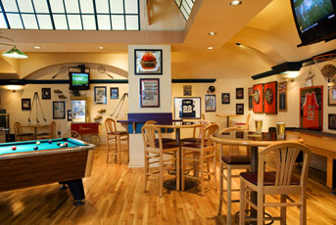

Ashley’s Restaurant
Sheraton Grand guests enjoy regional American specialties in Ashley's Restaurant. For breakfast, lunch, dinner or a snack, Ashley's features a varied menu of delectable items with something for everyone. Guests can also choose a bottle or glass of wine from our nationally recognized, award-winning Wine Cellar, a private dining chamber located inside Ashley's.

Breakfast & Lunch Dinner
Monday – Friday 6:30 A.M – 2:00 P.M. Monday –Sunday 5:00 P.M. – 10:30 P.M.
Saturday & Sunday 6:30 A.M. – 2:00 P.M.

AllStars Sports Bar/Lobby Bar
After a busy day, guests can join friends for cocktails in the elegant lobby bar or meet in AllStars Sports Bar to enjoy a snack and a favorite libation while watching sporting events on one of the 10 televisions, or engage in a game of billiards, shuffle board or darts.

AllStars Sports Bar Lobby Bar
Monday – Friday 5:00 P.M. – 1:00 A.M. Monday – Friday 11:00 A.M. – 7:00 P.M.
Saturday & Sunday 11:00 A.M. – 1:00 A.M.

Guest Room Dining
Guest room dining is available 7 days a week from 6:00 A.M. to 12:00 midnight when you want to enjoy your favorite dish in the privacy of your guest room.

GUEST SERVICES
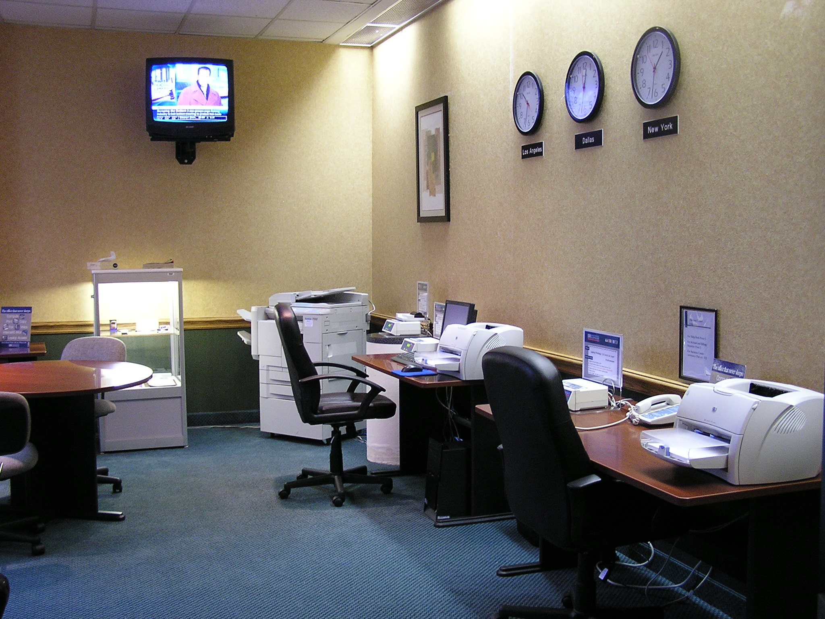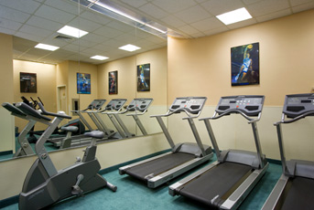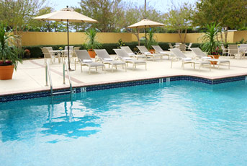
- Professional and courteous guest services staff
- 24-hour full-service Business Center
- 24-hour Fitness Center
- Gift Shop
- Same-day dry cleaning services available through guest services
- Guest room dining available 7 days a week from 6:00 A.M. to 12:00 Midnight
- Safe deposit boxes
- Express check-in and check-out
- 24-hour engineering department available to provide repair assistance
- Indoor/Outdoor heated pool

IN-ROOM AMENITIES

- Video entertainment and VCR rental available upon request
- Evening turndown service (upon request)
- Makeup mirror
- Hair dryer
- Iron and ironing board
- Coffeemaker and complimentary supply of coffee replenished daily
- Two telephone lines with data ports in each room
- High speed internet access
- Voice mail service

BUSINESS CENTER

The Business Center is open 24 hours a day, Sunday through Saturday. It is conveniently located on the Ballroom level adjacent to the pool and health club. Services include:

- Photocopying, Overhead Transparencies
- Fax Services
- Word Processing
- Printer hookups for PC and Laptop
- Desktop Publishing
- Spreadsheets

VIP GIFTS

The Sheraton Grand Hotel will be delighted to assist in arranging for specialty, themed or welcome gifts for your VIP guests.

Galleria Ballroom & Galleria Foyer
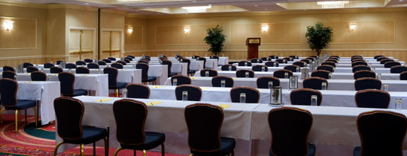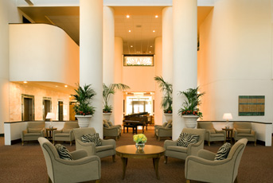
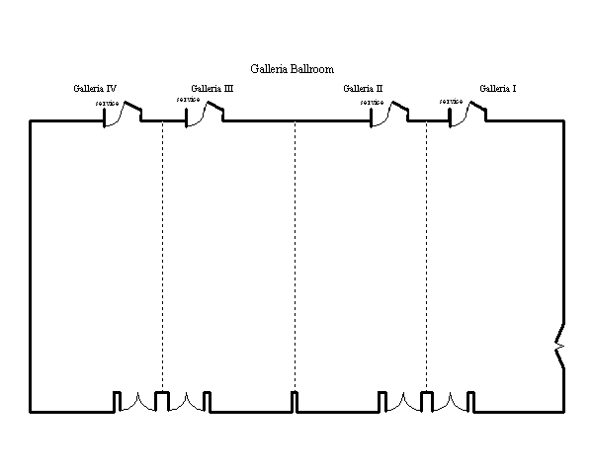

Galleria Ballroom | 48'x88' | 4,225 | 240 | 230 | n/a | n/a | n/a | 440 | 232 | 290 | 300
3 Bays | 48'x66' | 3,168 | 180 | 150 | n/a | n/a | n/a | 330 | 168 | 210 | 225
2 Bays | 48'x44' | 2,112 | 120 | 100 | 46 | 50 | 54 | 220 | 112 | 140 | 150
1 Bay | 48'x22' | 1,056 | 60 | 50 | 34 | 38 | 42 | 110 | 56 | 70 | 75
Mezzanine
Chagall |  | 1,236 | 50 | 40 | 30 | 25 | 29 | 80 | 56 | 60 | 60
One | 27'x28' | 756 | 30 | 26 | 20 | 18 | 20 | 50 | 32 | 40 | 40
Two | 24'x20' | 480 | 20 | 16 | 15 | 12 | 14 | 30 | 16 | 20 | 20
Dali |  | 1,008 | 40 | 40 | 25 | 22 | 24 | 65 | 32 | 40 | 50
One | 24'x20' | 480 | 20 | 16 | 12 | 12 | 14 | 30 | 16 | 20 | 25
Two | 24'x22' | 528 | 20 | 16 | 12 | 12 | 14 | 30 | 16 | 20 | 25
Miro | 26'x24' | 624 | 25 | 20 | 20 | 18 | 22 | 50 | 24 | 30 | 30
Renoir | 26'x24' | 624 | 25 | 20 | 20 | 18 | 22 | 50 | 32 | 40 | 30
Degas | 26'x24' | 624 | 25 | 20 | 20 | 18 | 22 | 50 | 32 | 40 | 30
Las Colinas Brdrm | 15'x24' | 360 | n/a | n/a | 14 | n/a | n/a | n/a | n/a | n/a | n/a
Boardroom Foyer | 11'x11' | 121
Estates Boardroom | 25'x18' | 450 | 14 | n/a | 16 | n/a | n/a | 18 | n/a | n/a | 20

Las Colinas Boardroom
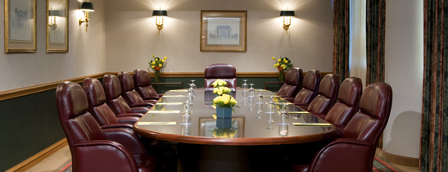

Room | Dimensions | Square Feet | Classroom | Chevron | Conf. | U-Shape | Hollow Square | Theatre | Rounds of 8 | Rounds of 10 | Recept.

Grand Ballroom & Atrium

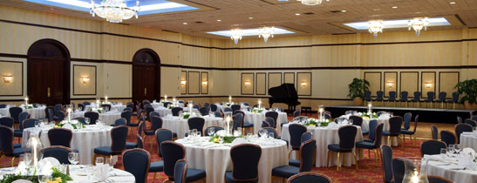
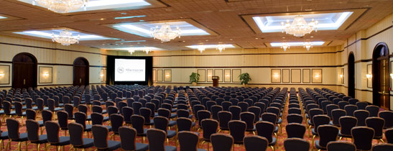
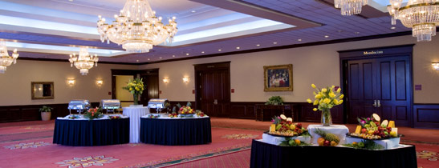

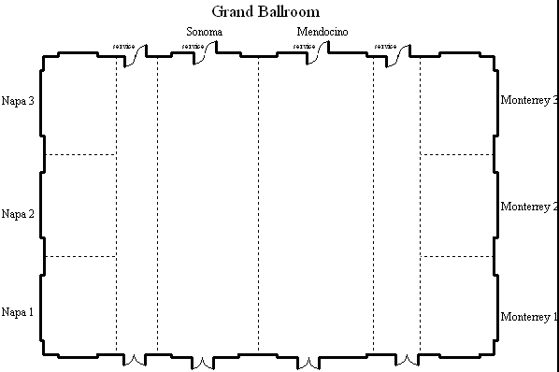

Room | Dimensions | Square Feet | Classroom | Chevron | Conf. | U-Shape | Hollow Square | Theatre | Rounds of 8 | Rounds of 10 | Recept.
Grand Ballroom
Pre-Function | 76'x55' | 4,180 | n/a | n/a | n/a | n/a | n/a | n/a | 208 | 260 | 300
Ballroom | 84'x120' | 10,080 | 700 | 650 | n/a | n/a | n/a | 1,300 | 744 | 930 | 930
3 Bays | 84'x87' | 7,308 | 465 | 455 | n/a | n/a | n/a | 860 | 480 | 600 | 600
2 Bays | 84'x60' | 5,040 | 310 | 300 | n/a | 90 | 110 | 600 | 320 | 400 | 400
1 Entire Bay | 84'x29' | 2,436 | 155 | 155 | n/a | 70 | 80 | 260 | 160 | 200 | 200
Napa/Monterey | 84'x21' | 1,764 | 155 | 155 | n/a | 70 | 80 | 260 | 160 | 200 | 200
2 Sections | 55'x2'1 | 1,155 | 60 | 60 | 48 | 46 | 52 | 100 | 72 | 90 | 90
1 Section | 27'x21' | 567 | 24 | 24 | 24 | 24 | 28 | 50 | 24 | 30 | 40
Cabernet | 17'x13' | 221 | 12 | n/a | 12 | n/a | n/a | 20 | 8 | 10 | 15
Chardonnay | 12'x12' | 144 | 10 | n/a | 8 | n/a | n/a | 15 | 8 | 10 | 12

Exciting Things to Do During Your Convention

Irving, Texas
The city of Irving is surrounded by a multitude of facilities that cater to the individual interests of your attendees. There are venues for everything including Arts & Entertainment, Parks & Recreation, Restaurants and Sports! Looking for a break from the city to enjoy a taste of Texas western life? Experience first hand
trail rides, cattle drives, western art and even campfire cooking! We are certain you will find exactly what
you are looking for. Irving has the perfect compromise of big city fun blended with Texas hospitality.

Visit http://www.irvingtexas.com or http://www.grapevinetexasusa.com for more information.

MEGA Shopping
- Grapevine Mills Mall features the best names in retail outlets, entertainment venues and themed
restaurants including Last Call from Neiman Marcus Clearance Center, Abercrombie & Fitch Outlet,
OFF 5th-Saks Fifth Avenue Outlet, GameWorks, Rainforest Cafe and AMC Theatres.
Located just two miles north of the Sheraton Grand DFW, Grapevine Mills is the first super-regional, value-oriented megamall in Texas and the Southwest.
(972) 724-4900 Phone - http://www.grapevinemills.com/static/node527.jsp
- Bass Pro Shops Outdoor World
- Irving Mall features more than 150 stores, including Macy’s, Dillard’s, Sears, Barnes & Noble, Old Navy and more!
- Shop the Historic Downtown Grapevine Association! Step back in time and relive the proud heritage of Grapevine's forefathers. Walk along the avenues of the historic Main Street District.

Wineries
Grapevine is home to many wineries and tasting rooms as well as the Texas Wine and Grape Growers Association. Tasting, as well as bottle and case sales, is available at the wineries. Many offer the perfect
setting for small gatherings and private functions.
http://www.grapevinetexasusa.com/visitors/wineries.asp

Activities
- Gondola Cruises @The waterways of the Mandalay Canals and Lake Carolyn in Irving's Las Colinas Urban
Center which has become home to two beautiful neo-Venetian gondolas.
- 81 holes of championship golf within 15 minutes of Sheraton Grand
- 3 million gallon aquarium with world’s longest walk-through tunnel-Opened 2005

Art Walk
- Irving Arts Center
- Grapevine prairie
- Explore many more options at http://www.irvingtexas.com/sd_attractions.php
Heritage Park
Located in the heart of the heritage district, the park contains a number of historic relics: Caster Cabin, one of Irving's original cabins, built in 1887 by Henry Caster; Irving's original water tower; a windmill original to the area; a depot symbolizing the Rock Island Depot built in 1903; Irving's first library building, opened in 1941; and a gazebo. Main Street at Second Street. (972) 721-2655

