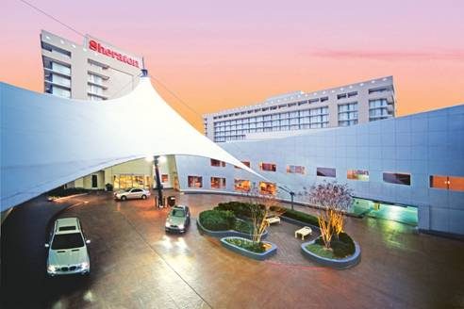

July 28, 2026
Mr. Larry Lampert
Aquatic Gardens Association
469-467-3872

Dear Mr. Lampert:

I am delighted that you are considering the Sheraton Atlanta Hotel as a possible host for your November 2008 Event. At the Sheraton Atlanta, we ensure that every aspect of your function is an overwhelming success. You will find our meeting facilities infinitely flexible, our staff exceedingly helpful, and our culinary expertise second to none.

Although we do not have your preferred dates available, we would like to propose the following alternate dates to accommodate your required guestrooms and function space.

CONFERENCE DATES:
November 13 – November 16, 2008

ANTICIPATED ROOM REQUIREMENTS:

 | Thu 11/13 | Fri 11/14 | Sat 11/15 | Sun 11/16
Single/Double | 40 | 50 | 50 | Checkout

GUEST ROOM RATES:

The Sheraton Atlanta Hotel is pleased to offer your group the following room rates

Single Rate | Double Rate
$109 | $109

The rates listed above are subject to state and local taxes, currently 15%.

A set-up and labor charge of $250 per day would be applied to cover all requested meeting space

ACCOMMODATIONS:

The hotel has 760 stunning guest rooms including 22 suites. All rooms feature:
- The Sheraton Sweet Sleeper® Bed which includes a plush pillow-top mattress set, a duvet comforter, and five cushy pillows
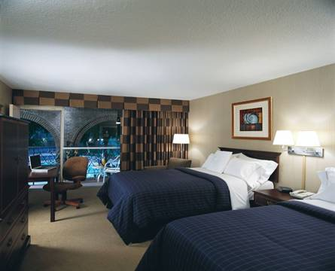
- Guest-Tek high-speed wireless Internet access
- Two-line telephones with voice mail
- On-demand video and viewing guide
- Individual heating and air conditioning controls
- Iron and ironing board
- Coffee maker
- Hair dryer
- Complimentary weekday newspaper

FUNCTION SPACE:
Many hotels offer a place to have meetings. The Sheraton Atlanta Hotel provides a dedicated, state-of-the-art conference center with 83,000 square feet of flexible function space. Our conference center was purposely built to accommodate every necessity for a productive meeting including electronic lighting, individual climate controls for each room, and sound dampening air walls in the ballrooms. All of the Sheraton Atlanta’s meeting space is equipped with the latest in T-1 high speed Internet access.

RESTAURANTS:
The Sheraton Atlanta offers three restaurant choices to meet all of your culinary requirements. Whether you are looking for a breakfast meeting, quick lunch, formal dinner, or a three a.m. snack, we have the perfect fit solution. Collage offers casual dining for breakfast and lunch from both a bountiful buffet and á la carte. Fandangles Restaurant and Martini Bar offers innovative American cuisine served nightly amid elegant surroundings overlooking the Savannah-style courtyard and pool. A fifty-foot curved bar offers eight Georgia themed signature martinis. If you are looking for something fast, yet fresh, the Deli is the place. Open 24 hours, it will please your palate with a refreshing array of delicious options at any hour.

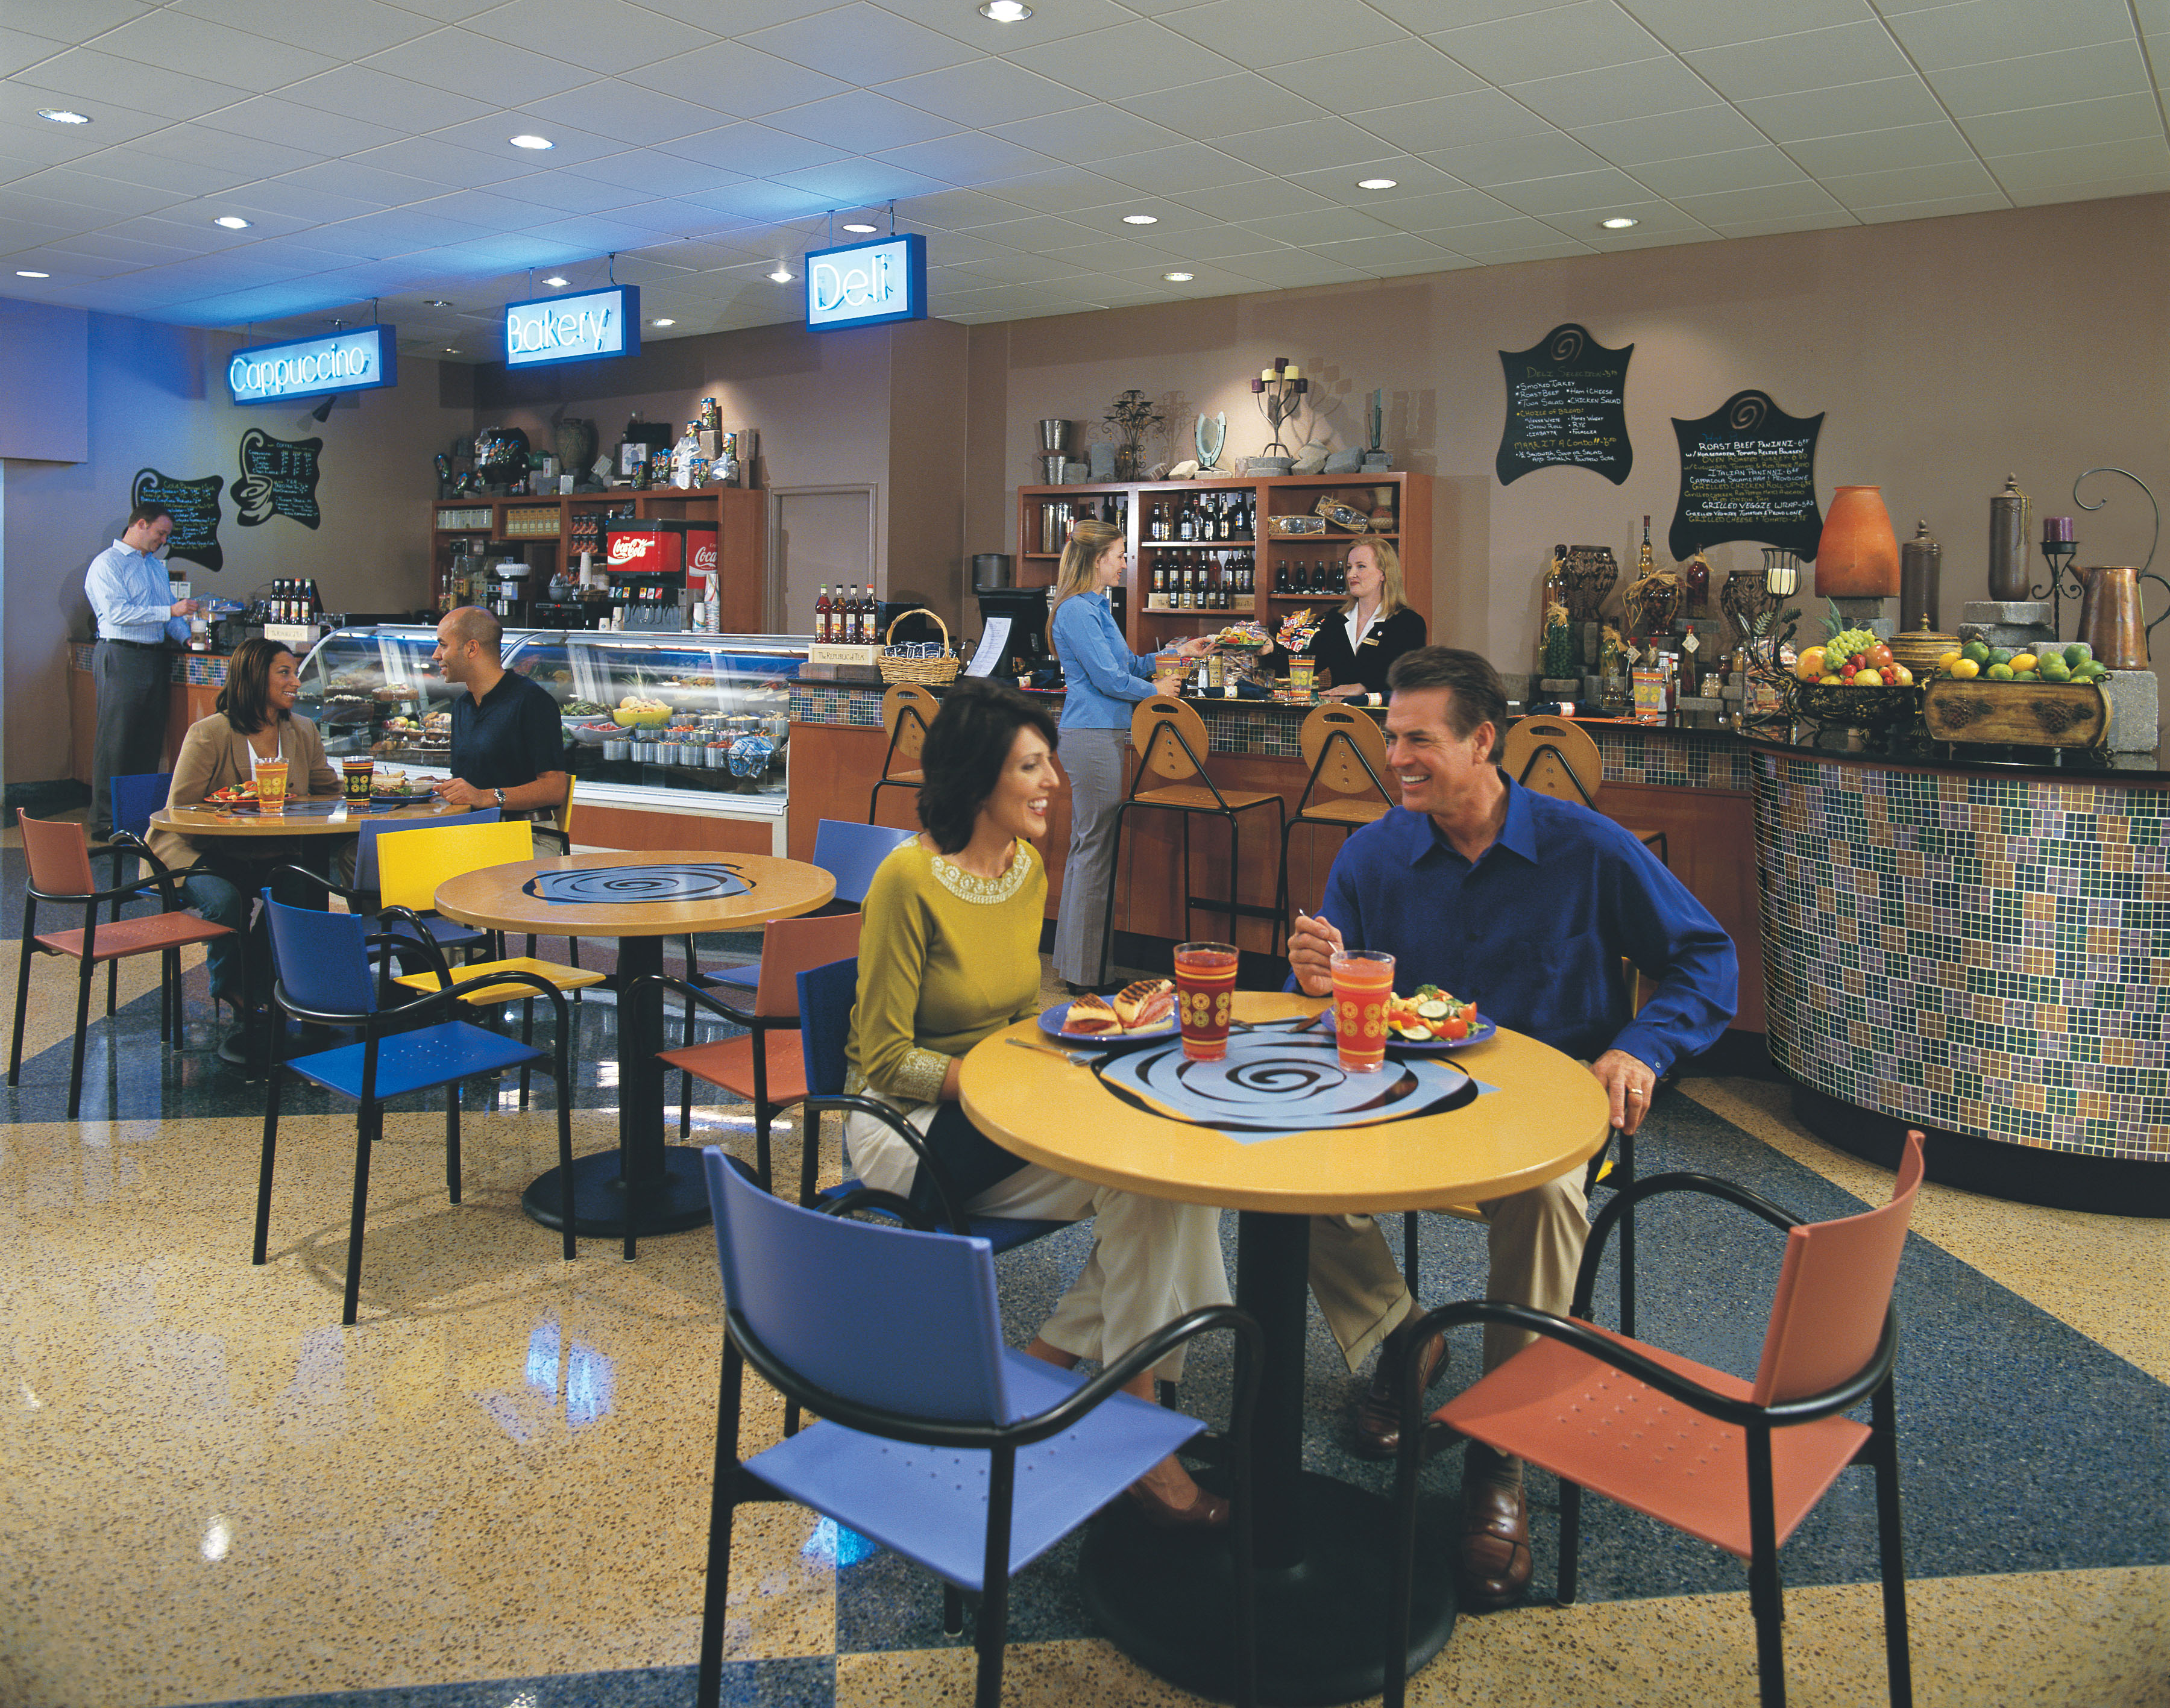

RECREATION:

Located in the heart of the hotel, the heated indoor pool is open year round and features a retractable glass roof. Located in our courtyard, the area flourishes with tall trees, flowing fountains, and beautiful flowers. The Jacuzzi and our large, 24 hour fitness center are located adjacent to the pool for your convenience.

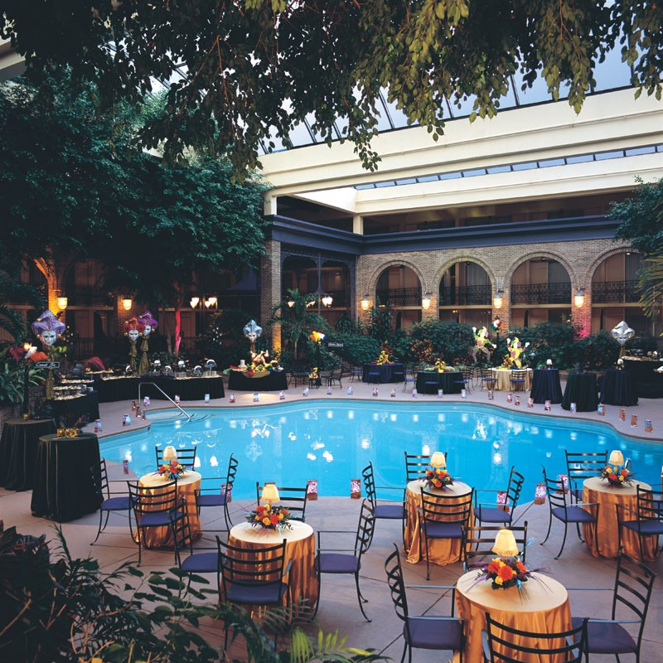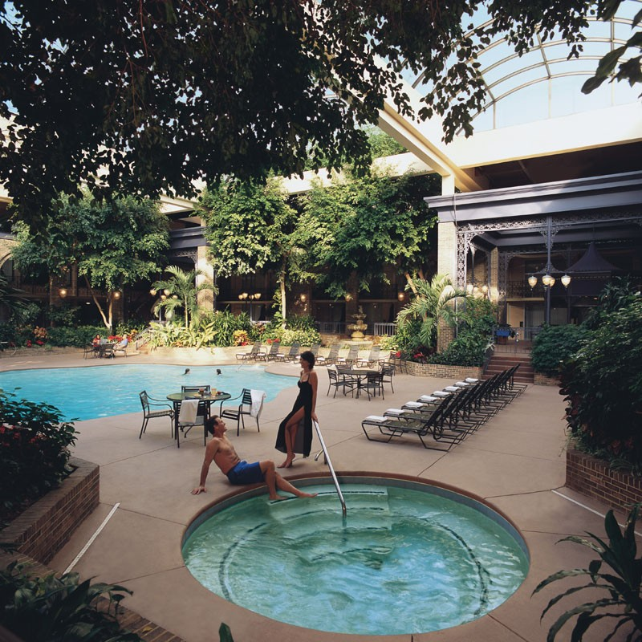
Indoor Savannah Style Garden Courtyard is Perfect for Receptions/Dinners up to 700 Guests

The Sheraton Atlanta Hotel is located in the heart of Atlanta’s convention, sports, and entertainment district, only minutes from the city’s most exciting attractions. Premier shopping, dining, and entertainment options are nearby including The Georgia Aquarium, Hard Rock Cafe, Underground Atlanta, CNN Center, Centennial Olympic Park, and Peachtree Center Mall. The Hotel is within walking distance of the Georgia World Congress Center.

LOCATION AND TRANSPORTATION:

- Easy access is available via Interstates 75/85 (off exits 248C, 249A)
- Parking is $18.00 self / $23.00 valet per day
- Atlanta’s economical rapid transit system, MARTA, available from the airport to Peachtree Center Station, just two blocks from the Hotel. MARTA costs $2.25 each way. (www.itsmarta.com)
- Atlanta Link provides shuttle service two times an hour and costs $16.50 each way or $29.00 round trip. (www.theatlantalink.com or 404-524-3400)
- Taxi’s cost approximately $25.00 each way.
- On-site transportation through International Limousine & Shuttle Services offers sedans, limousines, vans, and mini-buses for transportation needs. Prices vary. (404-589-8071)

The Hotel is located just 10 miles north of Hartsfield-Jackson International Airport.

SHERATON SPECIALTIES:

- Sheraton Service Promise® - If you’re not satisfied, we’re not satisfied. Sheraton’s Service Promise ensures you’ll have a great stay or we’ll make it up to you with an instant discount, points for our rewards program – or even money back. All you have to do is tell us.
- Starwood Preferred Guest and Planner Programs – www.starwood.com/preferredplanner
- StarGroups® Program –A customized web site for your group allowing attendees to register on-line and allows you to run pick-up reports (provided complimentary)
- Star Meeting Concierge – Dedicated on-site point of contact who ensures your meeting goes smoothly

ADDITIONAL INFORMATION:

- UPS Store on site
- On-site Audio Visual services through Tech Rentals
- Complimentary fitness center
- 24 hour room service
- 24 hour Deli/Bakery
- Concierge, member Les Clefs D’or

AWARDS:
The Sheraton Atlanta Hotel was the proud recipient of the following awards:

- Meetings and Conventions Magazine’s 2006 & 2007 Gold Key Award
- Corporate and Incentive Travel Magazine's 2006 & 2007 Award of Excellence
- Convention South's Reader's Choice Award
- Georgia Hospitality and Lodging Association’s Outstanding Special Event Award



You are also welcome to visit us on the Internet at www.sheratonatlantahotel.com. On behalf of the entire staff, your interest is very much appreciated, and we look forward to the prospect of having you and your attendees stay with us.

Best Regards,
Josh Baker
Josh Baker
National Sales Manager

