July 28, 2026

Mr. Larry Lampert
Meeting Coordinator
Aquatic Gardeners Association
7815 Yamini Drivie
Dallas, TX 75230

Dear Mr. Lampert:

Thank you for considering the exciting and sophisticated downtown Hilton Atlanta for your Aquatic Gardeners Association to occur in November of 2008. We value your business, and look forward to assisting you and your clients in achieving a most successful experience with us.

Our location is in the heart of downtown Atlanta, and has a capacity of over 115,000 square feet of the most flexible and reliable meeting space in town. The Hilton Atlanta is the ideal property to host this important meeting. We all look forward to making this event one of the best ever!

GUEST ROOM ACCOMMODATIONS:
Currently, the Hilton Atlanta is able to offer the dates of Thursday, November 13, 2008 - Sunday, November 16, 2008. We are pleased to offer the special group rates of $109.00 for single occupancy. This rate is net non-commissionable and exclusive of taxes, currently 15%. An upgrade to the Executive Level is available for an additional $40 per night based on availability.
 | Thu, 11/13/08 | Fri, 11/14/08 | Sat, 11/15/08
Run of House | 40 | 50 | 50

Total Room Nights: 140

MEETING SPACE REQUIREMENTS:
At this time, meeting space is currently available and can accommodate your meeting requirements. We are pleased to offer a Complimentary Meeting Space Rental based on 80% guest room pick-up. Otherwise, meeting room rental will be $500.00 per day. Please note, at this time we are not holding any space and all space is based on a first come, first serve basis unless held.
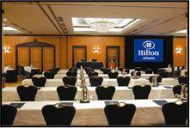
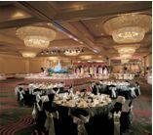
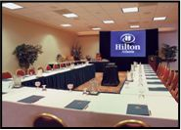

Please find below a few more highlights detailing how we can meet and exceed your objectives for your program.



- Location-The Hilton Atlanta is located in the heart of beautiful downtown Atlanta. We are within a few city blocks of world class fine dining, the Fox Theater, the Rialto Theater, the Georgia Aquarium, High Museum of Art, CNN, The World of Coca-Cola and many other recreational and cultural activities.



- Accessibility–Atlanta is within a two-hour flight of 80% of the U.S. population. This makes Atlanta one of the most accessible cities in the country. The Hilton Atlanta is only nine miles (15 minutes) from Hartsfield International Airport, and Delta Airlines is headquartered here! Plus we are just two short blocks from the nearest MARTA station. Shuttle service to/from the airport is $29.00 roundtrip.

- Upscale Guestrooms-The Hilton Atlanta has the largest sleeping rooms in downtown Atlanta. We recently completed renovation, which included two phone lines in every guestroom, 40 specially designed suites and 133 elegant Executive rooms. The Executive Level, “a hotel within a hotel” offers: private seated registration, turndown service, complimentary amenities such as continental breakfast, hot hors d'oeuvres, soft drinks and coffee. Guest room amenities include: bottled spring water, coffee maker, telephones, terry cloth robes, valet, and shoe stand buffer. They will definitely meet the needs of even the most discerning traveler.
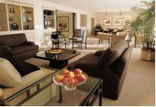
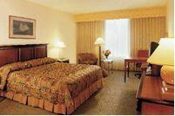

- Awards- Gold Key Award - Meetings & Conventions Magazine
Pinnacle Award - Successful Meetings Magazine
Inner Circle Award -Associations & Meetings Magazine
Hilton Pride Award for Continuous Improvement

- Parking-There are two choices for parking at the Hilton Atlanta: self-parking is $17.00 per day; valet is also available for $24.00 per day. We offer a great area for over-night bus parking at a low rate.

Please keep in mind that we are not holding space and the above quotes will remain in effect until November 16, 2007.

On behalf of the beautiful city of Atlanta, our outstanding staff, and myself, we look forward to welcoming the Aquatic Gardeners Association.

Sincerely,

Angela Sensenig

Conference Center Sales Manager
Hilton Atlanta
P: (404) 221-6959
F: (404) 222-2967
angela.sensenig@hilton.com

