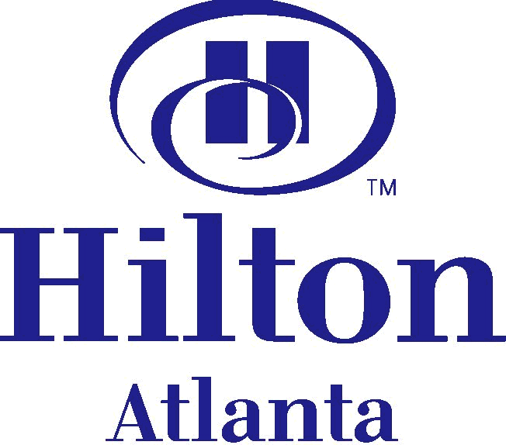
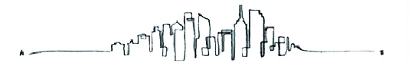
255 Courtland Street, NE
Atlanta, Georgia 30303
Phone: 404-659-200
www.atlanta.hilton.com

Travel is more than just A to B.
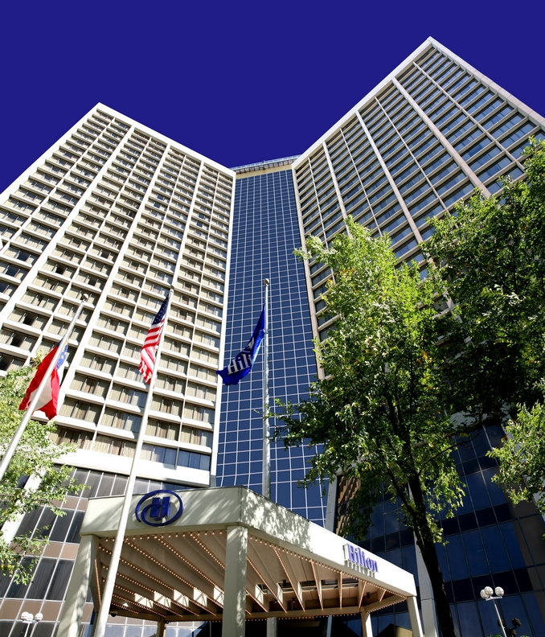
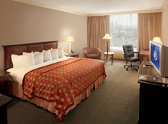
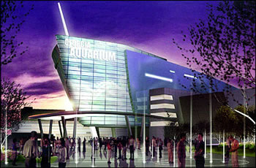

The Hilton Atlanta hotel offers the ideal setting for business or pleasure in downtown Atlanta, Georgia. We are 15 minutes from Hartsfield-Jackson International and we are conveniently located near the Georgia World Congress Center.

Nearby Attractions:

- Georgia Aquarium
- CNN Center
- Fox Theatre
- World of Coca-Cola Museum
- Philips Arena
- Martin Luther King Historical Center
Guest Rooms & Amenities:

- Largest guest rooms in downtown Atlanta
- 1226 Rooms
- 45 Suites
- 35 Accessible rooms
- Daily USA Today
- Full size work desk
- Wireless High-Speed internet access (daily fee)
- Hair Dryer
- LavAzza ‘in room’ coffee™
- Mini Bar
- In-room safe (laptop accessible)

Recreational Activities:

- Three outdoor tennis courts
- Full sized basketball court
- Jogging track
- Outdoor Swimming Pool
- Fully equipped fitness center
- Dry saunas and private showers



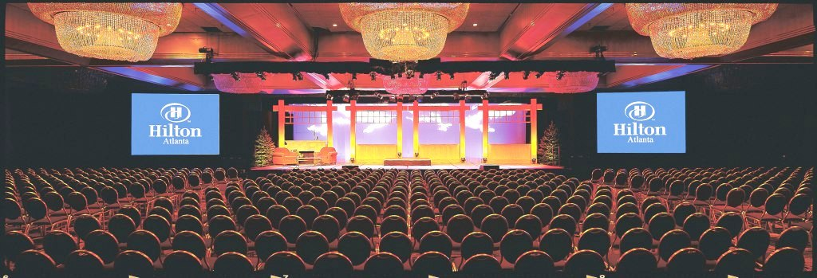



Conference Facilities:

- 115, 000 sq.ft of Flexible Function Space
- 63,000 sq. ft. SmartFlo™
- 41,000 sq. ft. open Exhibit Space
- In house Audio Visual Services
- Experienced & Creative Culinary Team

Hotel Restaurants:

- Nikolai’s Roof - A Point of View
- Trader Vic’s
- Le Café
- Café Express / 24 hr Deli
- Casablanca Lounge

For more information on Things to Do in Atlanta please visit
www.atlanta.net

DIRECTIONS: Traveling 75/85 South: Exit #249A Courtland Street. The Hotel is located 1 block ahead on the left. Traveling 75/85 North: Exit #248C, GA-10 East/Freedom Parkway toward Georgia World Congress Center . Turn left onto International Blvd. Turn right onto Piedmont (one way) and travel north approx 3 blocks. Turn left at Baker St. (one way) and travel west one block. Turn left at Courtland St. (one way). Hilton main entrance is located on the left.
Traveling 1-20: Follow to 75/85 North: Then follow directions above.

TRANSPORTATION: (prices are subject to change)
Shuttle: Transportation depot at Hartsfield International Airport. Tickets cost $16.50 one-way and $29.00 round trip. Round-trip tickets must be purchased at the airport. 404-524-3400 or www.theatlantalink.com
Taxi: Available at the Transportation Depot at the airport.
Marta: (Subway) Leaves directly from the airport. Exit Peachtree Center Station, cost: $1.75 per ride, per person. www.itsmarta.com
Parking: Self is $17.00 and Valet is $24.00 with In/Out Privileges – Prices are subject to change

