

2004 GSAS Home Show

Sign up to show off your tank(s) to the rest of the club!
The Home Show is open to all members, with no entry fee
Any tank - regardless of size, type, or style - can be entered

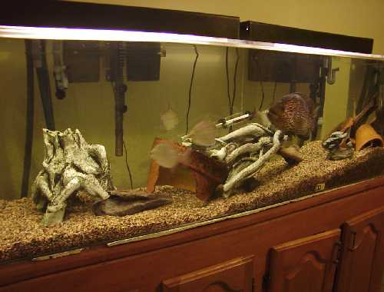

Contact Jeff Stewart (206) 297-1705
or e-mail gsasshow@excite.com to enter

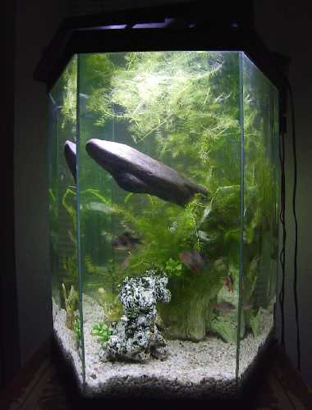

Homes will be visited by a small group, and photographs will be taken
Visits will be made the weekend of 1/24 – 1/25 or 2/21 – 2/22
Results will be presented at the March 9th Meeting

